Name: Tom T

Age: 19

Gender: Male

**Did you like the way the ship moves (the way it starts and stops moving), if not, why not?**

I like the way that the ships move, since if they were quicker they would be more difficult to control and therefore lead to bumping into asteroids.

**Did you like the speed of the rockets?**

I thought the speed of the rockets was very well balanced.

**What are your opinion(s) on the way the rockets explode and affect the asteroids?**

I think that the rockets affect the asteroids very well and felt that the asteroids had a genuiene reaction to the projectiles.

**Was the goal of the game readily evident when you started playing?**

The objective was not explicity obvious because i thought that i would also be able to hit the other player into the asteroids using the projectiles

**Do you like the art style? If not, what would you change?**

I think the art style is very nice but sometimes the ships can be lost in the background of space.

**Out of the options below, which UI do you prefer and why? What other information do you think should be included?**

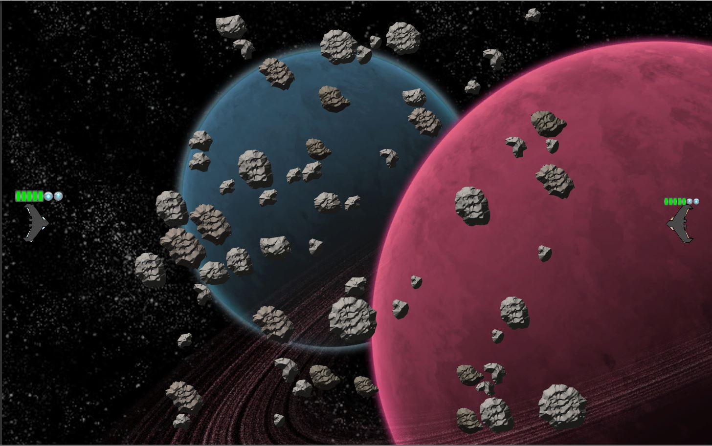

Figure : Same UI layout but different in size, is the right or left better?

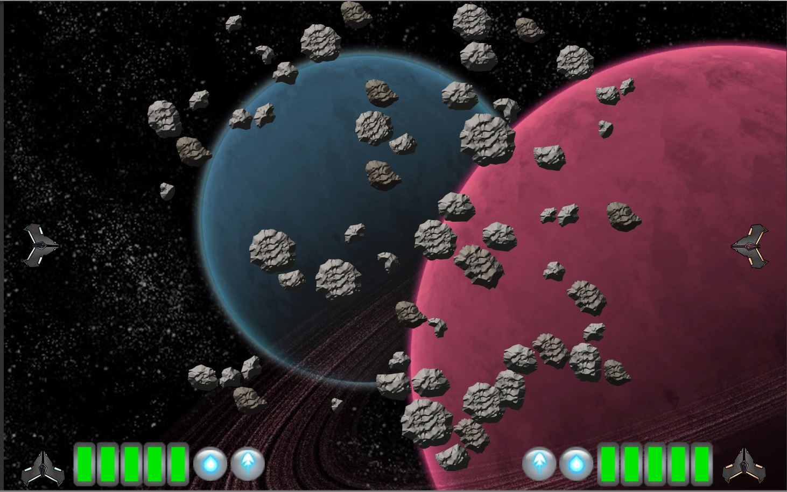

Out of the two UI designs i think that the first design would be much better since it is much easier to tell which bar belongs to which player

**If there is any missing information, what is it?**

None that i can see.

**Please give a short explanation of any bugs you have encountered**

I noticed that when i shot past the player and it hit the edge of the screen the nimation for the projectile still played and it hovered just at the edge.

A recommendation from me would be to make the players be able to use the push projectile to push other players into the asteroids, another suggestion wopuld be to make the players ships slighly lighter colours since they seem to get lost into the space background.